RESUME
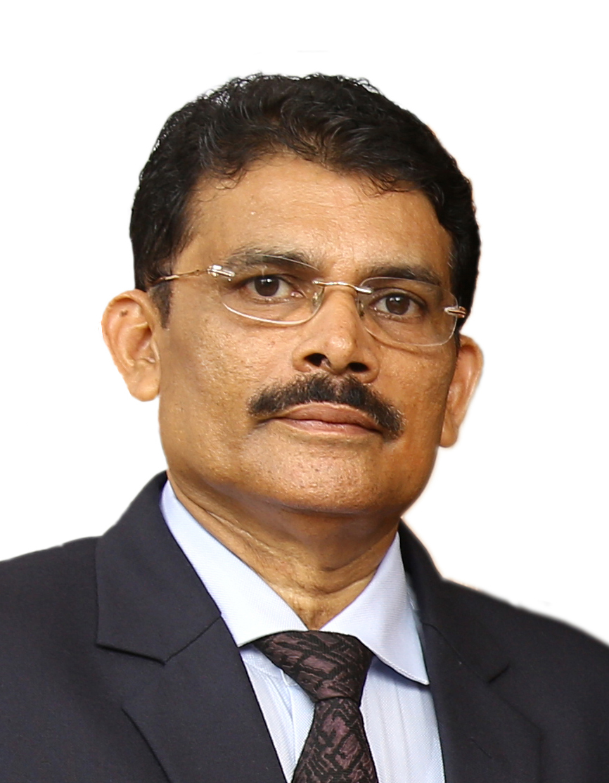

- Name : K.T.Joshy

- Gender : Male

- Date of Birth & Age : 02/04/1957, 60 Years

- Father’s Name : K.A.Thomas (late)

- Present & Permanent Address : 33/1498, JKS 48, Kandekkath Lane,
Perumbotta Road, Elamakkara. Cochin – 682026

- Contact Number & Email id : 8754543003, 9495215849. ktjoshy57@gmail.com
- Educational Qualification
Exam passed | University/Board | Year | Class | % | Subject
PhD Course work& Literature Review | Karunya Institute of Technology & Sciences Coimbatore | 3rd Semester Exam & Viva (December 2017) |  | 6.85 CGPA | HRM
PGDTRM | IGNOU(KMA) | 2014 | 1st | 81.26 | Management teaching & Research
MBA | IGNOU | 2010 | 1st | 64.02 | HRM
M.Phil | Cochin University | 1985 | 1st | 66.56 | Applied Economics
MA | SKV College  Calicut University | 1982 | 2nd | 55.47 | Economics
BA | Christ College  Calicut University | 1980 | 1st | 61.13 | Economics
Fellow of Insurance | Insurance Institute of India, Mumbai | 2005 |  |  | Insurance

8. Experience: Details of employment
Institution employed | From | To | Post held
Oriental Insurance, Cochin &  Chennai | July 2013 | April 2017 | Regional Manager  HR & Training
The Oriental Insurance Divisional Office Kottayam & DO 3, Cochin | July 2005 | June 2013 | Divisional Manager- 4 years  & Senior Divisional Manager- 4 years
The Oriental Insurance Co. Ltd.  Divisional Office Kottayam. | Aug 1998 | June 2005 | Asst. Divisional Manager  & Deputy Divisional Manager- 4 years
Oriental Insurance Co. Ltd. Chennai, Bangalore, Cochin. | July 1987 | Aug 1998 | Asst.Manager-7 years  & Administrative Officer- 4 years
NSSO, Ministry of planning | 1983 | 1987 | Investigator - 4 years
Nehru College (Private college) Valiaparamba. Trichur District | 1982 | 1982 | Faculty in Economics department-5 months

9. Details of Academic Workshop/Conference/ Seminar attended
Title | Institution | Date
Infusing Research Attitudes | Karunya University Coimbatore | 12/11/2016
Colloquium on Research Practices | Karunya University Coimbatore | 07/04/2017
International Conference ICCMCT’17 | Maharajas College Ernakulum | 23/12/2017

10. Details of Papers Published
Title | Institution | Date
“Job Satisfaction and its linkage with Training” ISBN: 978 -93-5300-37-5 | ICCMCT’17  Maharajas College Ernakulum | 23/12/2017

11. Details of important corporate Workshops/Trainings/Conferences attended
Title | Institution | Date
Leadership Competencies for Business Excellence | NIA, Pune | July 2016
Train the Trainer Training Programme | NIA Pune | June 2015
Organizational Renewal (HR) | NIA, Pune | Feb 2015
Insurance Technology Trends | NIA, Pune | Nov 2013
Transition-Middle Management to top Management | NIA, Pune | Aug 2013
Managerial Excellence | NIA, Pune | Sept 2012
Performance Excellence | OSTC Faridabad | May 2010
Retail Marketing Strategies | NIA, Pune | Sept 2009
General Management | NIA, Pune | Jan 2009
Refresher to General Managerial Learning | OSTC, Faridabad | Dec 2005
General Managerial Learning | OSTC, Faridabad | Sept-Oct 2004
Competency Enhancement & Skill Development | NIA, Pune | March 2004
Information Technology | NIA, Pune | July 2003
Supervisory Skills | OSTC, Faridabad | June 1995
Performance Management | OSTC, Faridabad | March 1994

Declaration

I, K.T.Joshy hereby declare and affirm that the details given above are true to the best of my knowledge and belief.
K.T.Joshy

